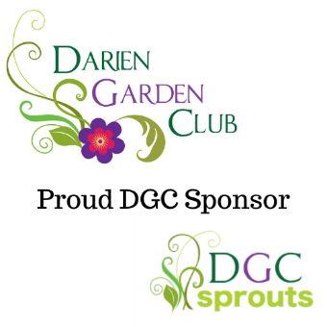

DGC Sponsorship Form

I. This is a Sponsorship Agreement dated as of ____________________________________________________________
between ___________________________________________________________________________________________
having a usual place of business at ______________________________________________________________________
(herein referred to as “Sponsor”) and the Darien Garden Club, (herein referred to as “The Club”). The Club is a not-for-profit member of The Garden Clubs of Illinois, Inc., having the usual mailing address of 1702 Plainfield Rd., Darien, IL 60561. The Club is recognized as a 501(c)(4) and will provide a W-9 upon request.
The Club was founded to encourage a nurturing environment where new and experienced gardeners, nature lovers, environmentalists, and those interested in horticulture can meet to share their experiences and get support from those who have similar interests. Our intentions are to encourage an interest in gardening, to increase knowledge of and promote respect for the natural environment, and to cultivate friendships with like-minded people. In addition to Club meetings, there are numerous local projects in which The Club is involved and many for which The Club is responsible. More information can be found on The Club’s website at: https://dariengardenclub.com/community-outreach
II. Club Year is defined as January 1st – December 31st. During the Club Year the Sponsor may identify itself as a sponsor of The Club. The Club will provide a Certificate of Appreciation for Sponsorship and Club business cards to all Sponsors.
III. The Sponsor desires to become a Sponsor of The Club and to provide one or more of the following:
- Gift in Kind Sponsor
Please describe and provide an estimated worth: ___________________________________________________
The Gift in Kind sponsor will be announced to all Club members and will be listed on The Club’s Sponsorship webpage for the Club Year within which it was received. A Gift in Kind Sponsor will also be listed in any related social media posts unless the choice of “Anonymous” is marked in Section IV below.
- One Time Meeting Sponsor (indicate which applies):
DGC Sprouts Youth Meeting ($150) Darien Garden Club General Meeting ($300)

The One Time Meeting Sponsor will be announced to all Club members and will be listed on The Club’s Sponsorship webpage for the Club Year within which it was received. A One Time Meeting Sponsor will also be listed in any meeting-related social media posts, the specific event (meeting) listing on Eventbrite, and on The Club’s website calendar announcing they are sponsoring that specific meeting unless the choice of “Anonymous” is marked in Section IV below.
- One Time Event Sponsor (check): $500

A One Time Event Sponsor will be announced to all Club members and will be listed on the Club Sponsorship webpage for the Club Year within it was received. A One Time Event Sponsor will also be listed in event-related social media posts and communications about the event unless the choice of “Anonymous” is marked in Section IV below.
- Yearly Sponsor (check): $1,500
w
A Yearly Sponsor will be announced to all Club members and will be listed on the Club Sponsorship webpage for the Club Year within which it was received. A Yearly Sponsor will also be listed in quarterly social media posts and communications throughout the Club unless the choice of “Anonymous” is marked in Section IV below.
IV. Sponsor Information
Name and Title of person filling out form _________________________________________________________________
Contact phone number _______________________________________________________________________________
Name of business ____________________________________________________________________________________
Business Address ____________________________________________________________________________________
Business Email ______________________________________________________________________________________
Business phone number ______________________________________________________________________________
Business website address _____________________________________________________________________________
Do you agree to be listed publicly on and in social media posts:
Yes No thank you, I would rather remain Anonymous.
w
w

Please return this form, jpeg formatted logos, and or PDF to: info@dariengardenclub.com
Without your contributions we would not be able to do what we do, so THANK YOU!

If you would like to support with a one-time donation or more, please visit our PayPal Donation link at:

CLUB USE ONLY
Club member that received/accepted form: Date:
Club member that received form on DGC Info email: Date:
Emailed copy should be given to each of the following:
President Vice President

Technology Committee Sponsorship Committee

